

Roxy –
Honeybees Class Teacher

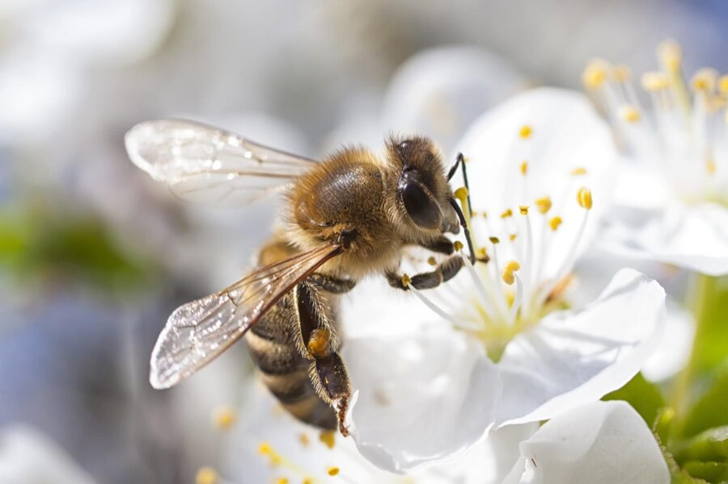
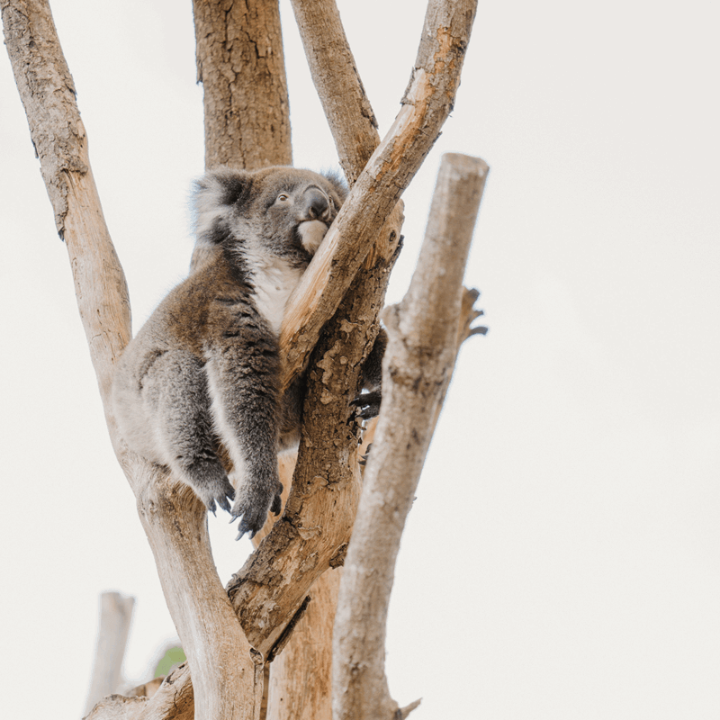
Katie –
Koala Class
Teacher


Year 1 2026-2027

Key dates for our Koala and Honeybees families

A warm welcome to our Year 1 families!

Your child’s teachers: Katie (Koala class) and Roxy (Honeybees class) have planned in lots of exciting opportunities for the children this year. The Year 1 team are looking forward to creating a wonderful learning environment for the children to explore.
Our topics for this year are:
Term 1: Marvellous Monarchy
Term 2: Let’s celebrate
Term 3: Land before time
Term 4: G’day mate
Term 5: Great women who changed the world
Term 6: Ever changing Earth.

To inspire and build a sense of awe and wonder we have planned in lots of exciting learning experiences. Below are some of the events for you to be aware of – reminders will be sent once dates are confirmed. Some of these will be informative workshops or parent’s evenings whilst other dates include trips and events. We would love to see as many of our families at the in-school activities as possible!

Term 5

In-school activities for parents and carers:
Sports Day (TBC)

In-school events for pupils:
Earth Day (TBC)
Sports Week (TBC)

Term 1
In-school activities for parents and carers:
- Back to School (03.09.26)
- Y1 Meet the Teacher for Parents (to be confirmed – last week of September)
- Parents’ evening (TBC)
In-school events for pupils:
Forest School – Activities focused on outdoor learning and play. This will happen every Wednesday afternoon.

Term 2
In-school activities for parents and carers:
KS1 Xmas Performance (TBC)
In-school events for pupils:
Individual school photographs
Anti-bullying week (TBC)
Remembrance Day (TBC)
Children in Need (TBC)
Theatre company – Pantomime (02.12.26)
Christmas Dinner & jumpers (TBC)

Term 3
In-school activities for parents and carers:
Parents’ evening (TBC)

In-school events for pupils:
Energy Saving Week (TBC)
Children’s Mental Health Week (wk.9th February)
*Potential Trip*:
Weston Museum – Dinosaurs & fossils day (TBC)
Term 4

In-school activities for parents and carers:
World Book Day activities week – book fair, dress up day TBC (wk. 2nd March)
In-school events for pupils:
World Book Day (5th March)
Science Week (wk.9th March)

Term 6

In-school activities for parents and carers:
Whole school art gallery (TBC)

In-school events for pupils:
Phonics Screening Check (TBC)
Art Week (TBC)

