Important Dates

Thursday 29th January – in school Birds of Prey Visit
Tuesday 3rd and Thursday 5th February – Parents evening
Tuesday 10th February – Year 2 Great Topic Round up @ 2.40
Friday 13th February - INSET day (school closed to children)

Phonics
At parklands we use the phonics scheme Unlocking Letters and Sounds.

Books will be changed every Wednesday, so please ensure previous books are returned, so that books can be swapped.

Oh, what a wonderful world
Year 2 Topic Web Term 3

Maths
Week 1 – Shape
Week 2 – Money
Week 3 – Money
Week 4 - Multiplication
Week 5 - Division
Week 6 – Multiplication and Division

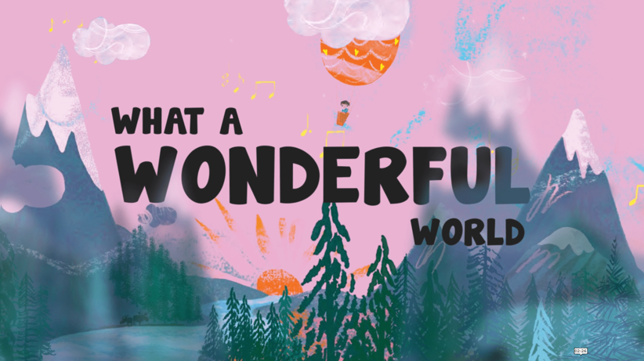
Geography
As geographers we will recap the hot and cold parts of the planet. We will then link learn about learning to animal habitats.

Science
Living things and their habitats
As scientists we will work scientifically by setting up a comparative test to find out and describe how plants need light, temperature and water to grow and stay healthy.
We will also be learning about what habitats are and that most living things live in habitats that are best suited to help them survive.
Learn Together
Our Value of the Term is Courage and Perseverance. In our Jigsaw lesson we will be setting goals and discussing our dreams for the future and what we think success looking like.

In Belief Systems, we are looking at changes to our local environment, thinking about whether changes are always good.

Art and DT
As artists we will be studying the creative work of Andy Goldsworthy and taking inspiration from his work to create our own natural art pieces.

English
As writers, we will be writing a Fear Tale and describing how our main character may overcome their fears. We will also be writing an acrostic poem linked to our topic. Finally, we will compose a non-chronological report linked to our science learning about habitats and Birds of Prey. We will continue to practise and refine our handwriting technique.

P.E.
Narwhal P.E. times: Wednesday
Tiger P.E. time: Wednesday

This term’s we will focus on: balance.

If you would like to contact the year 2 class teachers, please email info@parklandset.org.uk

Topic Vocabulary
Please read through these with your children and discuss their meaning. Why not try to incorporate some of these words into your day e.g. whilst playing or out for a walk.
English Writing - Vocabulary

Vocabulary linked to core text:
Frightened
terrified
Dazzling
magnificent
dark
midnight
inky
black
soft
fuzzy
fluffy
Vocabulary linked to grammar
- Statement
- Question
- Exclamation
- Command
- Adjectives
- Coordinating conjunctions: or/and/but
- Subordinating conjunctions: because./when/if/that
- Past and present tense
- Adverbs e.g. quickly
- Question mark
- Exclamation mark

Art

Material
natural
sculptures
manipulate
land art
observation
texture – smooth, soft, bumpy, spikey
curved

Geography
maps
landmarks
features
symbols
human and physical features
cliffs
coasts
hills
North
East
South
West
Equator
Hot
Cold
location

Science – habitats
habitat
needs
survival
alive
dead
food chain
animal
plants
warm
cold
dry
damp

Spelling
Common Exception Words

Yr 1:
said
were
was
they
friend

Yr 2:
beautiful
great
plant
could
should
would
grass
cold
-
Learn Together

Ready Respectful Safe
Courage
Perseverance
Goal
Dream
Success

Maths

Shape: corners, vertices, sides, straight, curved,
Money: coins, notes, pence, pounds, worth, value, change
Multiplication: times, groups of, lots of, altogether,

